Reading Activity (1)
Topic: Life on Earth
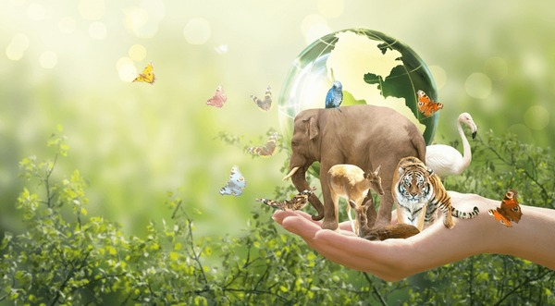

Objective: Understand key concepts about environmental preservation and endangered species.
Activity Description:
Read the following article excerpt on the importance of protecting the environment and animal species. After reading, answer the comprehension questions below.
Reading Passage:
"In recent years, environmental conservation has become increasingly important. Scientists warn that pollution, deforestation, and climate change are the biggest threats to our planet. Animal species are particularly vulnerable as their natural habitats are destroyed. Many species, such as tigers, polar bears, and elephants, face extinction. Clean air and water are crucial for all forms of life, and communities around the world are now promoting green practices to protect the environment. By recycling, using renewable energy sources, and reducing waste, individuals can make a positive impact. We all have a role to play in saving Earth."
Comprehension Questions:
What are the main environmental threats mentioned in the passage?
Which animal species are mentioned as being endangered?
According to the passage, how can individuals help protect the environment?
Check the right response :
What is one action that can help protect the environment?
(a) Using fossil fuels
(b) Recycling
(c) Cutting down more trees
(d) Ignoring pollution
Why is environmental conservation important?
(a) To help reduce traffic
(b) To protect the planet and all living things
(c) To increase deforestation
(d) To use more water resources

